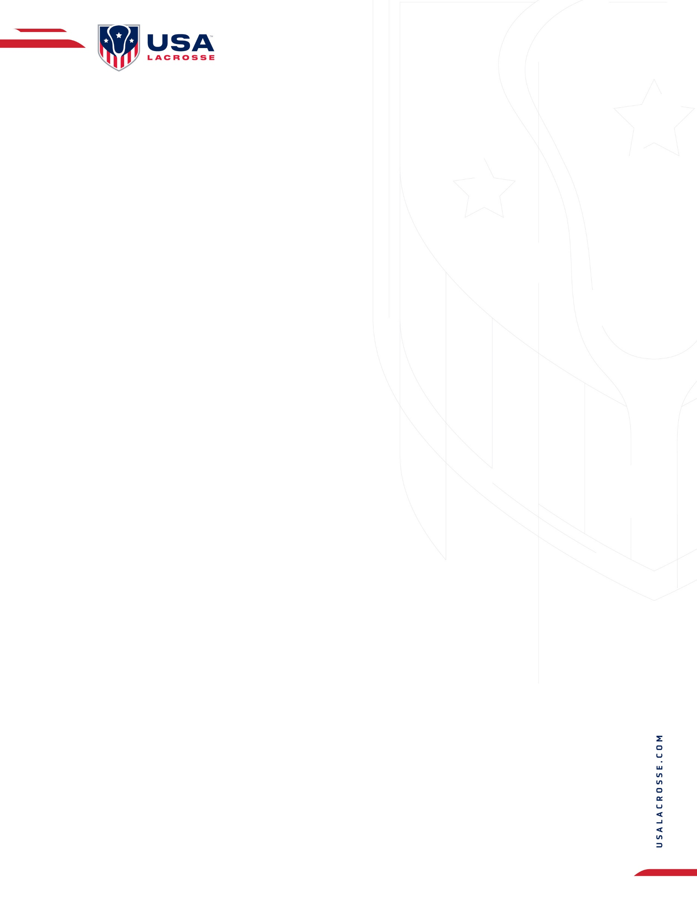
Incident Report (SAMPLE)

Unsportsmanlike Behavior / Significant Incident / Disqualification Resulting in Forfeit Report

This report is to be completed by the game Official(s), Directors and Coach(s) and e-mailed to {BLANK}. This must be submitted prior to the next scheduled game. Please specify below if this is Unsportsmanlike Behavior, Significant Incident, Disqualification or Game Action Forfeit.

Please mark one: ____ Unsportsmanlike Behavior _____Significant Incident _____ Disqualification
____Game Forfeit _____ Other
Date of Game: ____________________ Gender: ______ Boys _____ Girls
Grade: ______________ Location: ____________________________________________________
Home Team: _____________ Visiting Team: _____________________
Name of person(s) involved, in this incident: ____________________________________________
Role: ____ Coach ____ Player ____ Spectator ____ Official ____ Other
Issue: ___ Ejection ___ Rules Violation ___ Injury ___ Safety Concern ___ Behavior after End of Game

Please Explain Issue/Incident: _____________________________________________
_________________________________________________________________________________
_________________________________________________________________________________
_________________________________________________________________________________
Action Taken at the time: (Please provide as much information as possible, name(s) of the Official(s), Player(s), Coach(s), Spectator(s) or others that were involved or witnessed the incident. __________
__________________________________________________________________________________
__________________________________________________________________________________
__________________________________________________________________________________
E-mail to:

